编译原理 实验报告
实验名称 | 实验3 自底向上优先分析实验
姓名 | 付政昊 | 一卡通号 | 1520173738
专业班级 | 计算机中加171班 | 实验日期 | 5月27日
同组成员 |  | 得分

一、实验目的

1. 掌握简单优先分析法进行语法分析的方法。
2. 掌握算符优先分析法进行语法分析的方法。
3. 理解简单优先分析法与算符优先分析法的区别

二、实验内容

设布尔表达式文法G[B]：
B→BoT|T
T→TaF|F
F→nF| (B) | t | f
（1）G[B]是算符优先文法吗？
（2）若G[B]是算符优先文法，请编写其算符优先分析算法。

三、实验设计

FIRSTVT和LASTVT集合如下

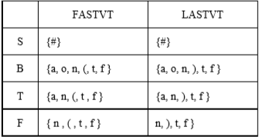
构建算符优先关系矩阵如下
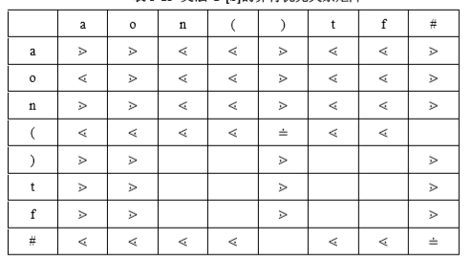

四、程序清单

#include <iostream>
#include<vector>
using namespace std;
#include<string>
#define ROW 9
#define COLUMN 9
#define PRODUCTS 8
int TokenIndex = 0;
string OperatorPrecedenceTable[ROW][COLUMN] = {
{ " ", "a", "o","n","(",")","t","f", "#" },
{ "a", ">", ">", "<", "<",">","<","<",">"},
{ "o", "<", ">", "<", "<",">","<","<",">" },
{ "n", ">", ">", "<", "<",">","<","<",">"},
{ "(", "<", "<", "<", "<","=","<","<",""},
{ ")", ">", ">", "", "",">","","",">"},
{ "t", ">", ">", "", "",">","","",">"},
{ "f", ">", ">", "", "",">","","",">"},
{ "#", "<", "<", "<", "<","","<","<","="}
};
string Grammar[PRODUCTS][2] = {
{"N","NoN"},
{"N","N"},
{"N","NaN"},
{"N","N"},
{"N","nN"},
{"N","(N)"},
{"N","t"},
{"N","f"}
};
string GetPrecedence(string ai,string aj)
{
string cell = "";
for (int i = 0; i < ROW; i++) {
for (int j = 0; j < COLUMN; j++) {
if (ai == OperatorPrecedenceTable[i][0] && aj == OperatorPrecedenceTable[0][j]) {
cell = OperatorPrecedenceTable[i][j];
break;
}
}
}
return cell;
}

string GetLHS(string RHS)
{
string LHS = "";
for (int i = 0; i<PRODUCTS; i++)
{
if (RHS == Grammar[i][1])
{
LHS = Grammar[i][0];
break;
}
}
return LHS;
}

int GetTopVtPos(vector<string> s) {
int i = s.size() - 1;
if (s[i] == "N")
i--;
return i;
}

string GetLpp(vector<string> s) {
int i = GetTopVtPos(s);
int k, k1;
k = k1 = i;
do
{
k = k1;
if (s[k - 1] == "N")
k1 = k - 2;
else
k1 = k - 1;
} while (GetPrecedence(s[k1], s[k]) == "=");
string lpp = "";
if (i<s.size() - 1 && s[i + 1] == "N")
i = i + 1;
if (k >= 1 && s[k - 1] == "N")
k = k - 1;
for (int j = k; j <= i; j++) {
lpp.append(s[j]);
}
return lpp;
}

bool OPA(string inputstring)
{
int i, k;
bool flag = false;
TokenIndex = 0;
string lpp, lhs;
string X, a, Precedence;
vector<string> stacks;
stacks.push_back("#");
a = inputstring[TokenIndex++];
while (true) {
i = GetTopVtPos(stacks);
X = stacks[i]; Precedence = GetPrecedence(X, a);
if ((Precedence == "<" || Precedence == "=") && a != "#")
{
stacks.push_back(a);
a = inputstring[TokenIndex++];
} else if (X == a&&a == "#")
{
flag = true;
break;
} else if (Precedence == ">") {
lpp = GetLpp(stacks);
lhs = GetLHS(lpp);
if (lhs != "")
{
for (int j = 0; j<lpp.size(); j++)
stacks.pop_back();
stacks.push_back("N");
} else {
flag = false;
break;
}
} else {
flag = false;
break;
}
}
return flag;
}
int main()
{
string symbolstring;
while (cin >> symbolstring) {
bool flag = OPA(symbolstring);
if (flag)
cout << "syntax correct" << endl;
else
cout << "syntax error" << endl;
}
return 0;
}

五、结果分析
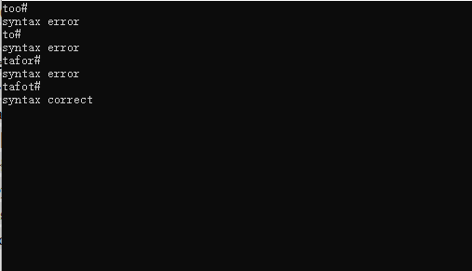

六、实验总结

掌握了简单优先分析法和算符优先分析法进行语法分析的方法。

